**OCASA Board Meeting Minutes**

**September 19, 2023**

**4:00pm, Lake Silver Elementary**

**Members Present:**  Anna Diaz, Seth Daub, Adriene Anderson, James Morosetti, Nate Hay, Kip Montgomery, Nicolle Campbell, Danielle Brancato, Guy Swenson, Alex Heidelberg, Desiree Houghton, Alex Jackson, Doug Loftus

Meeting started at 4:00 P.M.

Secretary Report: Minutes for 8.29.2023 were approved as written. A motion was made by Adriene to approve the minutes from the meeting on 8.29.2023. Treasurer James Morosetti 2nd the motion and the minutes were approved by the board.

Treasurer Report: James shared the Treasurer’s report. The balance for checking is approximately $1,956.52 and savings $7,157.72.

**Introductions Nate**

Assist Director Rep for Technical Colleges. Teresa Saffold Washington

**High School (Nicolle Campbell)**

1. **Students are being charged $10 for the replacement of chargers but it is costing the schools $30-$40 to replace the chargers. They only last for 1 year so the schools are losing out in the budget. Warranty should be reviewed and possibly charge the students more for the fine since it is costing 3x to replace them.**
2. **Revisiting the budgets because schools are not allocated the appropriate resources to support students. We should revisit the budget and ask the question: Are their equity in services being provided at schools? We need to revisit I owe you’s and determine if the principal can be given a grace period of three years to payoff the money owed. We need to have a budget model that is clear and precise to the needs of the schools.**

**Middle School (Amy McHale)**

1. **Buses still an issue including proper supplements and communication.**
2. **Digital budgets and replacement costs.**
3. **Systems for tracking and notifying families regarding digital fines. I don’t know that we have addressed this one. Discussion for new CIO possibly. Tracking and notifying parents of due fines and the processes around clearing the student fines (two system process and they don’t speak to each other) daunting for Media Specialists especially with new book legislation requirements.**

**Elementary School (Kip Montgomery)**

1. **Administrators are feeling overwhelmed with the visits and Literacy Plan expectations. Principals are constantly being pulled from building to training to bring back to the school to train the leadership teams and implement a plan that takes time and planning. The timing and implementation of the Literacy plan is not clear. What is the priority? Administrators feel that they don’t have enough time to prepare.**
2. **Exact Path and Success Maker computer-based programs are not being implemented with fidelity due to the lack of training for teachers and administrators.**
3. **Advanced Degrees Supplement – What is the status on the compensation study and when was it going to be communicated to the principals**

**Technical School (Alex Heidelberg)**

**Pay Increases for Administrators**

**Committee Reports**

Membership Report **Monica**

* **Members 316 New total as of 9/19/23**
* **Deductions from last payroll cycle $1,638.00 ($5.25 rate)**
* **Dr. Gordon has a message going out the general membership to support this committee.  We have two confirmed returning members**
* **The graph below will use used to target Cadres and potential new members.**

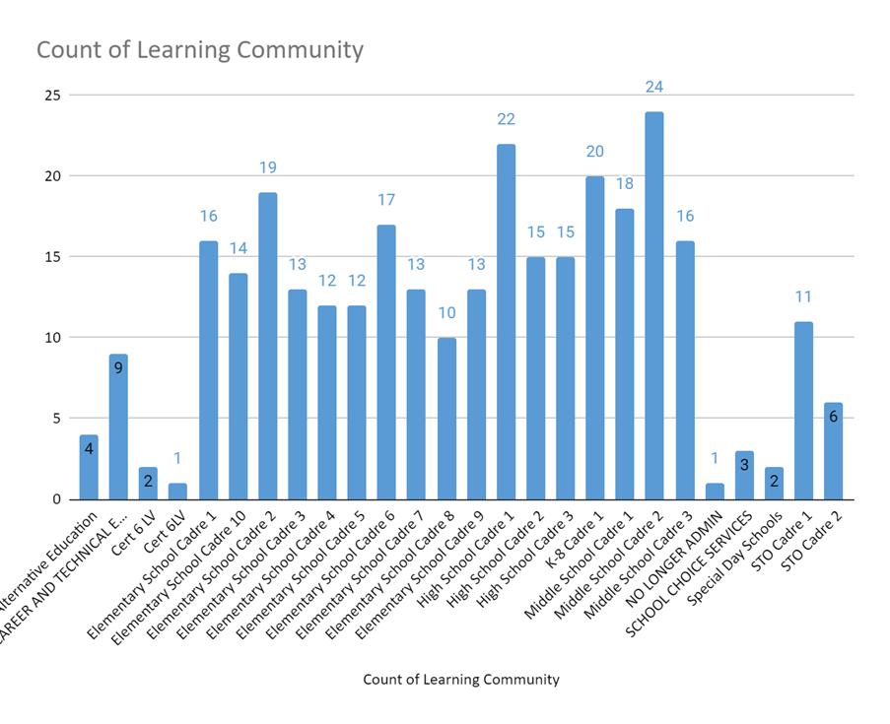

Events **Alex J.**

* **Dr. Jackson is looking to do an event before the Christmas break for Members of OCASA. A survey will be sent out to see what activity they would like to do next. The budget for this event will be $2000. The 1st 40 people that RSVP will be paid for in whatever event that OCASA chooses to have.**

Public Relations/Marketing **Seth**

* **Seth is still working on creating accounts for OCASA as it relates to social media.**

Legal and Advocacy **Matt**

* **The PD of Professional Standards was very productive and we may offer it again. We are working making sure the setting for the virtual PDs are secure so that only OCASA members can attend.**

Professional Development **Kip**

* **Kip is working on coming up with other PDs in the near future.**

**Old Business**

* + Representative Board Vacancies
    - Fundraising – Teresa King: Audubon Park School K-8
  + FASA Days
    - President reported out who will attend this event: Matt, Monica, Guy, Nate, Anna, and a Middle School Representative.

**New Business**

* + Survey Results for latest Survey
  + [name@OCASA.net](mailto:name@OCASA.net)
    - Board agreed to continue to use OCPS emails as a point of contact instead of using an OCASA.net email address
  + Need Photos
    - Photos are needed for the new representatives to the Board

**Open Discussion**

**OCASA Executive Board Meeting with Deputy Superintendent Agenda Items**

* **Communication to Principals on Compensation Study**
* **Elementary Schools – Compressed Timing of Development and Implementation of New Programs/Initiatives/Systems**
* **Budget and Equity of Services**
* **Survey Results – Deputy Superintendent Newsletter**
* **Permission to have a few minutes at Principals and AP cadre meetings by a member from the cadre.**
* **Technology concerns regarding fines vs. actual cost to schools.**
* **Clarification on Administrator pay on the Hurricane Day**

**Other Business:**

**Meeting scheduled for November 14th will be Face to Face instead of virtual**

**Next Meeting Date:**

**October 17, 2023, Lake Silver at 4:00PM**

**Meeting Adjourned @ 5:30 p.m.**